Day 27 - Report
Task - Student Study Habits and Performance Dashboard Creation
Objective:
The objective of this dashboard is to analyze students' study habits and academic performance. A new column named StudyCategory was created using the Conditional Column feature in Power BI based on students' weekly self-study hours. Various visualizations were then created using this output column to identify study patterns and their relationship with student performance.

Data Preparation
A new column called StudyCategory was added using the Conditional Column option.
Conditions Used:
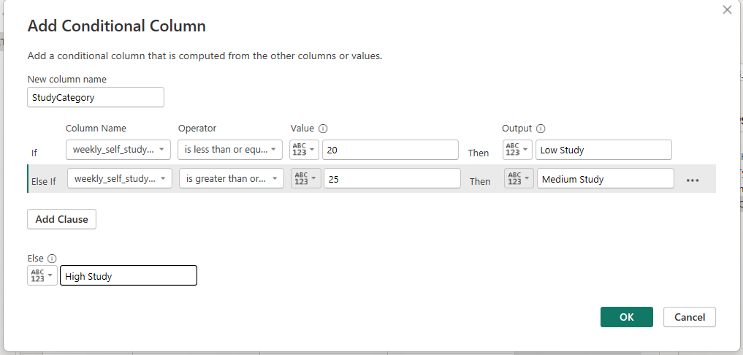
Weekly Self Study Hours | StudyCategory
Less than 20 Hours | Low Study
Greater than or equal to 25 | Medium Study
else | High Study
This categorization helped group students according to their study habits.
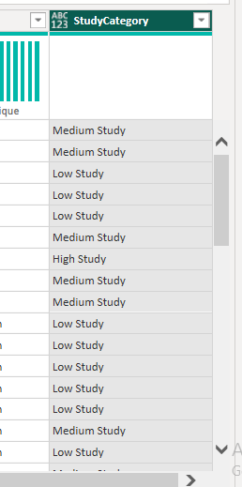

Dashboard Visualizations
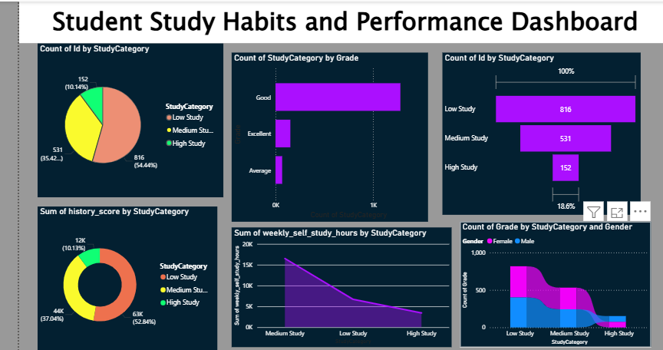
1. Pie Chart – Count of Students by StudyCategory
This chart displays the distribution of students across Low Study, Medium Study, and High Study categories.
Insight:
Most students belong to the Low Study category, while fewer students fall into the High Study category.

2. Clustered Bar Chart – Count of StudyCategory by Grade
This chart shows how students from different performance grades are distributed among study categories.
Insight:
Students with Good grades form the largest group compared to Average and Excellent grades.

3. Funnel Chart – Count of Students by StudyCategory
This visualization presents the number of students in each study category using a funnel representation.
Insight:
The Low Study category contains the highest number of students, followed by Medium Study and High Study.

4. Donut Chart – Sum of History Score by StudyCategory
This chart compares the total History scores achieved by students in different study categories.
Insight:
Students in the Low Study and Medium Study categories contribute a larger share of total History scores due to their higher population.

5. Area Chart – Sum of Weekly Self Study Hours by StudyCategory
This chart visualizes the total self-study hours accumulated within each study category.
Insight:
The Medium Study category records the highest cumulative study hours among all categories.

6. Stacked Area Chart – Count of Grade by StudyCategory and Gender
This chart compares male and female student distributions across study categories.
Insight:
Both genders are represented across all study categories, allowing comparison of study patterns between male and female students.

Conclusion
A new output column named StudyCategory was successfully created using Conditional Column logic. Using this single calculated column, multiple visualizations were developed to analyze student study behavior and academic performance. The dashboard provides valuable insights into student distribution, study patterns, grade performance, subject scores, and gender-based analysis, helping educational institutions better understand student learning habits.
Tools Used: Power BI Desktop
Data Transformation: Conditional Column (StudyCategory)
Visualizations Used: Pie Chart, Clustered Bar Chart, Funnel Chart, Donut Chart, Area Chart, and Stacked Area Chart.

